
Vol 15, Issue 1, (2026) E-ISSN: 2226-6348

A Bibliometric Review of Modeling Competencies: Mapping Research Trends and Knowledge Structure

Jian Fen Wang
Department of Chemistry, Faculty of Science and Mathematics, Sultan Idris Education University, Malaysia & Department of Chemistry, Heng Shui University, China
Email: 31536693@qq.com
DOI Link: http://dx.doi.org/10.6007/IJARPED/v15-i1/27591
Published Online: 06 February 2026
Abstract
Modeling is widely recognized as a core scientific practice and a key component of science learning. Although research on modeling and modeling competencies has expanded substantially in recent decades, the overall knowledge structure and thematic development of this field remain insufficiently synthesized. To address this gap, this study presents a bibliometric review of modeling-related research in science education. Using the Scopus database, 322 English-language journal articles published between 1990 and 2023 were analyzed with CiteSpace. Publication trends, keyword co-occurrence networks, and thematic clusters were examined to map the evolution and structure of the research field. The results show a sustained increase in modeling-related studies since the mid-2010s, with a strong focus on instructional practices and technology-supported modeling environments. In contrast, studies that explicitly conceptualize modeling competencies as integrated learning outcomes, particularly in secondary education contexts, remain limited.By systematically mapping research trends and thematic relationships, this review clarifies the current landscape of modeling research and identifies underexplored directions for future inquiry. The findings provide a foundation for advancing theoretically coherent and empirically grounded research on modeling competencies in science education.
Keywords: Modeling Competencies, Scientific Modeling, Science Education, Bibliometric Review, Citespace

Introduction
Modeling is widely recognized as a fundamental practice in science, serving as a primary means through which scientific knowledge is constructed, represented, and communicated. In scientific inquiry, models are used to explain phenomena, generate predictions, and support theory development (Gilbert et al., 2000; Schwarz et al., 2009). Accordingly, science education has increasingly emphasized engaging students in modeling activities to promote deeper conceptual understanding, scientific reasoning, and participation in authentic scientific practices (Treagust et al., 2004). In parallel with this pedagogical emphasis, the concept of modeling competencies has emerged to describe learners’ abilities to understand, construct, apply, and critically reflect on scientific models. Research in science education has examined modeling competencies from multiple perspectives, including instructional design, learning processes, and assessment (Schwarz & White, 2005; Nicolaou & Constantinou, 2014). Collectively, these studies indicate that modeling competencies involve not only engagement in modeling practices but also metacognitive and epistemological understanding of the roles and purposes of models in science.

Despite growing scholarly interest, research on modeling and modeling competencies spans diverse disciplinary contexts, educational levels, and methodological approaches, resulting in a broad yet fragmented body of literature. Existing reviews have contributed important conceptual syntheses, particularly with respect to theoretical frameworks and instructional strategies (Justi & Gilbert, 2002; Nicolaou & Constantinou, 2014). However, most prior reviews have relied primarily on narrative or systematic approaches, which, while informative, provide limited insight into large-scale research patterns, thematic structures, and the evolution of research interests over time.

In recent years, bibliometric analysis has been increasingly adopted as a complementary approach for synthesizing rapidly expanding and conceptually diverse research fields. By applying quantitative techniques and visualization tools to large bibliographic datasets, bibliometric methods enable researchers to examine publication trends, identify dominant themes, and detect emerging or underexplored research areas (Zupic & Čater, 2015; Donthu et al., 2021). Within science education, bibliometric approaches have proven particularly valuable for clarifying knowledge structures and tracing the development of research domains that integrate multiple theoretical and methodological traditions.

Taken together, this scholarship demonstrates both the educational importance of modeling and the rapid expansion of research addressing modeling-related teaching and learning. Yet, because the literature spans multiple domains, educational levels, and methodological traditions, it remains difficult to obtain an integrated picture of how research topics are connected, which themes dominate the field, and where key gaps persist.

To address this need, the present study offers a bibliometric mapping of modeling and modeling-competency research in science education. By combining Scopus coverage with CiteSpace visualization, this review contributes to the social sciences by (a) revealing the knowledge structure and thematic evolution of modeling research, (b) identifying underexplored strands focusing on modeling competencies as integrated learning outcomes, and (c) proposing evidence-based directions for future research and assessment in secondary education contexts.

Literature Review
Accordingly, the purpose of this study is to conduct a bibliometric review of research on modeling and modeling competencies in science education using data retrieved from the Scopus database. Employing CiteSpace as the analytical tool, this study analyzes publication trends, keyword co-occurrence networks, and thematic clusters to systematically map the research landscape and knowledge structure of the field. By providing a comprehensive overview of the development and positioning of modeling competencies research within the broader modeling literature, this study aims to inform future research directions and support more coherent and cumulative inquiry in science education.
Research on modeling competencies has expanded substantially over the past two decades, reflecting the growing recognition of modeling as a core scientific practice and a central component of science learning. Early empirical studies documented that many learners tended to interpret scientific models as concrete replicas of reality rather than as abstract representations or explanatory tools, revealing fundamental challenges in students’ epistemic understanding of models (Grosslight et al., 1991; Ingham & Gilbert, 1991). These findings laid the groundwork for subsequent efforts to conceptualize modeling competencies as multifaceted constructs that integrate both engagement in modeling practices and reflective understanding of the nature and purpose of models. Over time, theoretical perspectives have increasingly converged on the view that modeling competencies consist of interrelated components, including modeling practices, domain-specific knowledge embedded in models, and metacognitive or epistemological knowledge about models and modeling (Schwarz & White, 2005; Nicolaou & Constantinou, 2014; Nielsen & Nielsen, 2021). Core modeling practices frequently identified in the literature include model construction, comparison, revision, and validation (Stratford et al., 1998; Penner et al., 1997; Schwarz & White, 2005). More recent conceptual syntheses have emphasized the dynamic interactions among these components, characterizing modeling competencies as developmental and evolving rather than as static skill sets (Chiu & Lin, 2019).

In parallel with these conceptual developments, research has increasingly framed modeling as an iterative process central to both scientific inquiry and learning. Modeling is commonly described as a cyclic activity involving the development, application, evaluation, and revision of models to explain and predict phenomena (Gilbert et al., 2000; Treagust et al., 2004). Educational studies have highlighted the cognitively demanding nature of modeling, including processes of conceptualization, representation, and simulation (López-Vargas et al., 2017), while also noting that many science curricula continue to offer limited opportunities for students to actively construct and refine their own models (Justi & Gilbert, 2002). In response, a range of instructional frameworks and modeling cycles have been proposed to scaffold students’ engagement in modeling practices and support the progressive development of modeling competencies (Schwarz et al., 2009; Chiu & Lin, 2019).

A substantial body of empirical research has focused on instructional approaches designed to cultivate modeling competencies across science domains. Model-based teaching approaches emphasize students’ active participation in constructing, evaluating, and refining models as part of learning activities (Khan, 2011). In chemistry education, in particular, modeling-based approaches have been shown to support students’ understanding of abstract and representational concepts by enabling them to use models in ways analogous to scientific practice (Dori & Kaberman, 2012; Chiu & Zeng, 2023). Recent studies have continued to refine modeling-oriented instructional sequences, proposing design principles that guide students’ progression from model recognition and representation toward model application and construction. These studies underscore the importance of coherent instructional scaffolding in modeling-based learning environments, as reflected in recent instructional design research published in 2024 and 2025. Alongside instructional research, considerable attention has been devoted to the assessment of modeling competencies. Early assessment studies documented students’ limited epistemic understanding of models, prompting the development of multidimensional instruments such as the Students’ Understanding of Models in Science (SUMS), which assess students’ views of models as representations, explanatory tools, and evolving constructs (Wei et al., 2014). Subsequent reviews have identified persistent challenges in modeling assessment, including inconsistencies in dimensional definitions, limited validation of measurement instruments, and insufficient alignment between assessment frameworks and instructional goals (Nicolaou & Constantinou, 2014).

More recent research has increasingly operationalized modeling competencies using multidimensional and developmental frameworks, often distinguishing competencies related to model cognition, representation, application, and construction (Yang, 2017; Li & Yu, 2023). Findings from these studies consistently indicate uneven development across competency dimensions and educational levels, suggesting that modeling competencies do not progress uniformly and that targeted instructional and assessment support is required. Extending this line of inquiry, empirical studies published in 2024 and 2025 have focused on validating modeling competency assessment instruments using advanced psychometric approaches and refining evaluation frameworks to better capture students’ developmental trajectories, reflecting ongoing efforts to strengthen methodological rigor in this area.

In addition, emerging research has begun to explore the role of technology in supporting both modeling instruction and assessment. Recent studies highlight growing interest in technology-enhanced visualization tools, digital modeling environments, and artificial intelligence–supported assessment methods, pointing to new possibilities for capturing students’ engagement in modeling practices and evaluating complex learning outcomes. Although this line of research is still developing, publications from 2024 and 2025 suggest an expanding technological and methodological landscape that is likely to influence future research on modeling competencies.

Taken together, existing literature indicates that research on modeling competencies constitutes a diverse and rapidly evolving field characterized by multiple conceptual perspectives, instructional approaches, and assessment frameworks. While prior narrative and systematic reviews have provided valuable conceptual syntheses of modeling competencies research ( Nicolaou & Constantinou, 2014), a comprehensive mapping of research trends, thematic structures, and knowledge evolution across this expanding body of literature remains limited. To address this need, the present study employs bibliometric and visualization techniques using CiteSpace to systematically analyze the research landscape, identify major thematic clusters, and trace the developmental trajectories of modeling competencies research in science education.

Methodology
Research Design
This study adopts a bibliometric review design to systematically map research trends, thematic structures, and knowledge evolution in modeling competencies research within science education. Bibliometric analysis combines quantitative techniques with scientific visualization to examine large bodies of literature and has been widely applied to identify intellectual structures, research frontiers, and developmental patterns across academic fields (Zupic & Čater, 2015; Donthu et al., 2021). In this study, bibliometric methods were used to complement traditional narrative reviews by providing an objective, transparent, and reproducible overview of the research landscape.
Data Source and Search Strategy
Bibliographic data were retrieved from the Scopus database, which is widely recognized as one of the most comprehensive abstract and citation databases of peer-reviewed literature. Scopus is frequently used in bibliometric research due to its extensive journal coverage and standardized citation information, which support robust co-occurrence and co-citation analyses (Donthu et al., 2021).

The literature search was conducted in March 2024, and publications from 1990 to 2023 were included to capture both the early development and recent growth of modeling-related research. The search was limited to peer-reviewed journal articles and review papers published in English to ensure academic quality and data comparability.

A topic-based search strategy was applied using the following query in the TITLE-ABS-KEY field:
TITLE-ABS-KEY (“modeling competence” OR “modelling competence” OR “scientific modeling” OR “model-based learning” OR “modeling skill”). To enhance relevance, retrieved records were screened to retain studies situated in educational and learning contexts, while publications unrelated to education were excluded through manual review. All eligible records were exported in plain text format, including full bibliographic information and cited references, and subsequently imported into CiteSpace for analysis.

Bibliometric Analysis Procedures
CiteSpace (version 6.1R6) was employed as the primary tool for bibliometric analysis and visualization (Chen, 2016). CiteSpace is a scientific knowledge mapping software designed to analyze patterns and trends in academic literature through co-occurrence, co-citation, clustering, and citation burst detection techniques. It has been widely applied in bibliometric studies across disciplines, including science education and educational technology research (Chen, 2016; Jian & Wu, 2023).

The bibliometric analysis followed commonly adopted CiteSpace-based procedures. First, bibliographic records were imported into CiteSpace and preprocessed, with the time span divided into one-year slices to capture annual variations in research activity. Second, keyword co-occurrence and clustering analyses were conducted to identify major research themes and knowledge structures. Third, co-citation and timeline analyses were performed to examine the intellectual structure of the field and the temporal evolution of key themes. Network indicators, including frequency, betweenness centrality, silhouette values, and citation burst strength, were used to evaluate the importance, coherence, and emergence of identified themes and publications. Finally, the visualized results were interpreted in conjunction with descriptive statistics to reveal research trends, thematic relationships, and developmental patterns in modeling competencies research.

Results
Publication Output and Temporal Distribution
Based on the Scopus database, a total of 322 English-language journal articles related to modeling and modeling learning or teaching were identified between 1990 and 2023 (Figure 1). As shown in Figure 1, research output remained relatively limited throughout the 1990s, followed by a gradual increase after 2000. A more pronounced growth trend emerged from approximately 2014 onward, with publication output peaking around 2019–2020 and remaining at a comparatively high level through 2023, when 35 articles were published. Overall, the temporal distribution indicates a sustained expansion of modeling-related research over the past decade.

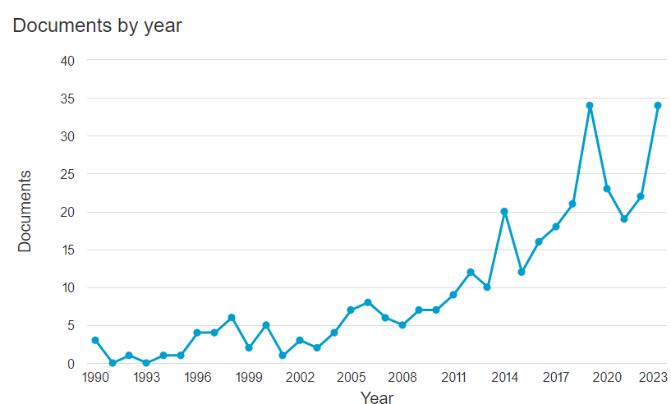

Figure 1 Annual distribution of publications on modeling and modeling-related research (1990–2023)

Keyword Co-occurrence Network and Cluster Structure
To examine the thematic structure of modeling-related research, a keyword co-occurrence analysis was conducted using CiteSpace, with keywords selected as the node type. The resulting network comprises 322 nodes and 1,293 links, yielding a network density of 0.0114. This indicates a relatively sparse yet interpretable network structure. The weighted mean silhouette value (S = 0.9564) suggests a high level of internal consistency and reliability among the identified clusters. Cluster analysis based on the log-likelihood ratio (LLR) algorithm generated 13 major thematic clusters, which are summarized in Table 1 and visualized in Figure 2. Cluster size was used as an indicator of relative research activity within each thematic area. The two largest clusters, biology student (Cluster #0, n = 39) and team-based learning (Cluster #1, n = 39), reflect substantial research attention to modeling in biological education contexts and collaborative learning environments. These clusters include keywords related to teaching modeling, conceptual models, and structural equation modeling.

Several other clusters indicate sustained interest in instructional and technology-related aspects of modeling research. The instructional practice cluster (Cluster #2, n = 35) and the educational technology acceptance model cluster (Cluster #3, n = 32) highlight research addressing pedagogical strategies and technology adoption. Clusters focusing on video modeling examples (Cluster #4, n = 31) and molecular modeling software (Cluster #5, n = 31) further underscore the prominent role of digital tools and visualization technologies in modeling-related studies.

Smaller clusters represent more specialized or methodologically oriented research themes. For instance, the competencies model cluster (Cluster #6, n = 18) includes keywords associated with competency frameworks and graphical modeling. Clusters such as model misspecification (Cluster #7, n = 17) and robust prior distribution (Cluster #10, n = 11) reflect statistically oriented modeling research. The high school science cluster (Cluster #12, n = 7), although relatively small, represents a distinct research strand focusing on model construction and modeling activities in secondary education contexts.

Table 1
Keyword Clustering Table of the Literature on Model and Modeling from Scopus Database
Cluster ID | Size | Cluster Header | Label (LLR)
0 | 39 | biology student | biology student (23.75, 1.0E-4); teaching modeling (23.75, 1.0E-4); engineering student (23.75, 1.0E-4); mathematical model (23.75, 1.0E-4); exploratory structural equation modeling bifactor model (19.73, 1.0E-4)
1 | 39 | team-based learning | team-based learning (21.5, 1.0E-4); life science (21.5, 1.0E-4); using Partial Leasts Square (21.5, 1.0E-4); conceptual model (21.5, 1.0E-4); Structural Equation modeling (21.5, 1.0E-4)
2 | 35 | instructional practice | instructional practice (22.72, 1.0E-4); targeted professional development (22.72, 1.0E-4); student learning (22.72, 1.0E-4); secondary technology (19.83, 1.0E-4); engineering education (19.83, 1.0E-4)
3 | 32 | educational Technology Acceptance  Model | educational Technology Acceptance Model (22.47, 1.0E-4); using parametric multi-group analysis (22.47, 1.0E-4); the-job training module development (22.47, 1.0E-4); reciprocal relationship (19.21, 1.0E-4); using Structural Equation modeling (19.21, 1.0E-4)
4 | 31 | video modeling example | video modeling example (24.73, 1.0E-4); human model (24.73, 1.0E-4); group dynamics (19.69, 1.0E-4); shared attitude (19.69, 1.0E-4); agent-based model (19.69, 1.0E-4)
5 | 31 | molecular modeling software | molecular modeling software (14.57, 0.001); n-pentane (14.57, 0.001); torsional energy surface (14.57, 0.001); using molecular model (14.57, 0.001); new exploration (14.57, 0.001)
6 | 18 | competencies model | competencies model (17.36, 1.0E-4); graphical modeling (17.36, 1.0E-4); hydrological modeling flow forecasting (8.51, 0.005); teaching (8.51, 0.005); efficient hydrology model (8.51, 0.005)
7 | 17 | model misspecification | model misspecification (9.76, 0.005); ability (9.76, 0.005); posterior predictive checking (9.76, 0.005); growth mixture modeling (9.76, 0.005); instructional practice (0.14, 1.0)
8 | 17 | 4d digital landscape model | 4d digital landscape model (9.76, 0.005); continuous soil (9.76, 0.005); application (7, 0.01); instructional practice (0.14, 1.0)
9 | 14 | systematic method | systematic method (10.43, 0.005); building (10.43, 0.005); urban building energy modeling (10.43, 0.005); instructional practice (0.11, 1.0); Structural Equation modeling (0.11, 1.0)
10 | 11 | robust prior distribution | robust prior distribution (9.25, 0.005); latent (9.25, 0.005); categorical model (9.25, 0.005); multilevel Structural Equation modeling (9.25, 0.005); investigation (9.25, 0.005)
11 | 9 | modeling | modeling (15.3, 1.0E-4); questionnaire data (15.3, 1.0E-4); hierarchical measurement model (15.3, 1.0E-4); partial credit (15.3, 1.0E-4); longitudinal random item response model (7.55, 0.01)
12 | 7 | high school science | high school science (14.25, 0.001); model (14.25, 0.001); model construction (14.25, 0.001); students design (14.25, 0.001); bifocal modeling framework (14.25, 0.001)

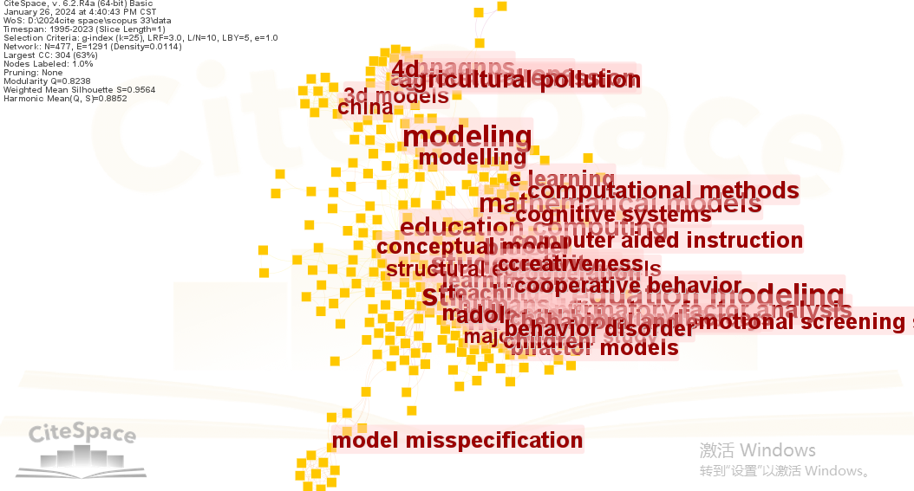

Figure 2 Keyword co-occurrence network and thematic clusters of modeling-related research based on Scopus data

Thematic Relationships and Knowledge Structure
The cluster visualization in Figure 2 illustrates the relationships among the identified thematic areas. Several clusters exhibit relatively strong interconnections, indicating overlapping research interests. In particular, clusters related to biology student (Cluster #0), team-based learning (Cluster #1), and educational technology acceptance model (Cluster #3) are closely connected within the network. Similarly, the video modeling example (Cluster #4) and molecular modeling software (Cluster #5) clusters form a tightly linked group, reflecting shared emphasis on digital and visual supports for modeling processes.

In contrast, clusters associated with competencies model (Cluster #6) and high school science (Cluster #12) show comparatively weaker connections to the central clusters. This pattern indicates that research explicitly addressing modeling competencies, particularly within secondary education contexts, occupies a more peripheral position within the broader modeling research landscape.

Summary of Bibliometric Findings
Taken together, evidence from publication trends (Figure 1), keyword co-occurrence networks and thematic clusters (Figure 2 and Table 1), and thematic evolution (Figure 3) reveals a research landscape characterized by sustained growth and increasing thematic diversification. Modeling-related research has increasingly focused on instructional practices and technology-supported environments, whereas studies explicitly centered on modeling competencies, especially at the high school level, represent a smaller and less interconnected strand. These results provide a structured overview of the knowledge landscape and establish an empirical basis for further discussion of research gaps and future directions.

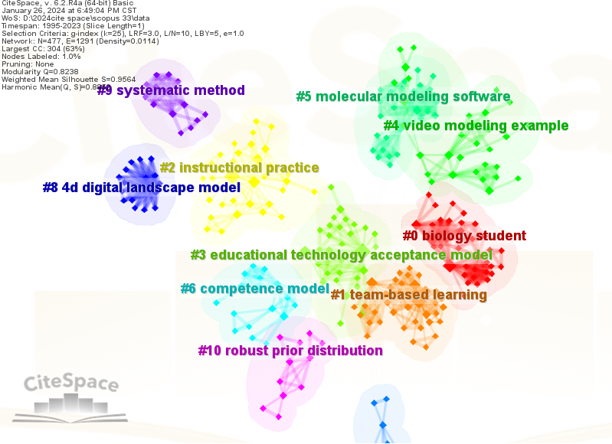

Figure 3 Timeline visualization of thematic evolution in modeling-related research

Conclusions and Discussion
This bibliometric review provides a systematic overview of research on modeling and modeling-related studies over the past three decades. By integrating publication trend analysis, keyword co-occurrence networks, and thematic cluster mapping, the study outlines the knowledge structure and developmental patterns of this research field. The findings indicate sustained growth in modeling-related research, particularly since the mid-2010s, reflecting increasing recognition of modeling as a core scientific practice and an important component of science learning and instruction (Gilbert et al., 2000; Schwarz et al., 2009).

One key finding of this study is that modeling-related research has been strongly oriented toward instructional practices and technology-supported learning environments. Large and densely connected clusters related to biology education, team-based learning, educational technology acceptance, video modeling examples, and molecular modeling software demonstrate that a substantial proportion of studies have focused on pedagogical strategies and digital tools designed to support students’ engagement in modeling activities. This emphasis aligns with broader trends in science education that prioritize learner-centered instruction and the integration of educational technologies to enhance conceptual understanding and scientific reasoning (Dori & Kaberman, 2012; Chiu & Zeng, 2023).

In contrast, the bibliometric results indicate that research explicitly addressing modeling competencies as coherent and assessable learning outcomes remains comparatively limited and fragmented. Although a distinct competence-related cluster was identified, it was smaller in size and less densely connected to the dominant instructional and technology-oriented clusters. This pattern suggests that, while modeling is widely adopted as an instructional approach, fewer studies have systematically conceptualized, operationalized, and evaluated modeling competencies in an integrated manner. Similar challenges have been noted in prior reviews, which highlighted inconsistencies in competency frameworks and limited alignment between modeling practices, meta-knowledge, and assessment approaches (Nicolaou & Constantinou, 2014; Nielsen & Nielsen, 2021).

The analysis further reveals that research focusing on secondary education contexts, including high school science, occupies a relatively peripheral position within the broader modeling research landscape. Given the importance of modeling competencies in supporting students’ progression toward advanced scientific reasoning and disciplinary understanding, this relative marginalization warrants attention (Justi & Gilbert, 2002; Chiu & Lin, 2019). Empirical studies have reported uneven development of modeling competencies across dimensions such as model cognition, representation, application, and construction, underscoring the need for more targeted, developmentally sensitive instructional and assessment research in secondary education settings (Yang, 2017; Li & Yu, 2023).

From a methodological perspective, this study demonstrates the value of bibliometric and visualization-based approaches for synthesizing large and conceptually diverse bodies of literature. By mapping thematic clusters and their interconnections, bibliometric analysis makes visible dominant research streams as well as underexplored areas that may be overlooked in traditional narrative reviews (Chen, 2016; Zupic & Čater, 2015). In this review, such an approach clarified the relative positioning of modeling competencies research within a broader literature largely shaped by instructional and technological themes.

Beyond summarizing publication patterns, this review advances a competencies-oriented perspective on scientific modeling by clarifying how instructional, technological, and assessment strands cluster—and often remain loosely connected—within the literature. The mapping reveals that research explicitly conceptualizing modeling competencies as coherent, multidimensional learning outcomes remains comparatively peripheral, particularly in secondary education. By making these structural relationships visible, the study contributes to social science knowledge through a transparent evidence base for theory building, including the alignment of modeling practices, meta-modeling knowledge, and competency-oriented assessment. At the same time, it informs curriculum design, teacher professional development, and educational technology development in contexts where modeling is emphasized but systematic, competency-focused evaluation is still limited. Together, these contributions support more cumulative, comparable, and context-sensitive research on how students develop modeling competencies over time.

It should be noted that the temporal scope of this review, which includes literature from the early stages of modeling research through recent publications, represents a deliberate analytical choice rather than a limitation. Bibliometric analysis is designed to capture longitudinal development, thematic continuity, and shifts in research focus over time. By integrating foundational studies with recent contributions from 2024 and 2025, this review provides a comprehensive perspective on how modeling competencies research has emerged, diversified, and evolved within science education. Several limitations should nevertheless be acknowledged. First, the analysis was limited to English-language journal articles indexed in the Scopus database, which may exclude relevant studies published in other languages or indexed elsewhere. Second, bibliometric analysis relies on citation data and metadata rather than direct examination of instructional quality or learning outcomes, and therefore cannot substitute for in-depth empirical investigations of teaching and learning processes (Donthu et al., 2021).In conclusion, this bibliometric review reveals a research landscape characterized by sustained growth and increasing thematic diversification, with strong emphasis on instructional practices and technology-supported modeling environments alongside comparatively limited and fragmented attention to modeling competencies as learning outcomes. By systematically mapping research trends and knowledge structures, this study provides a consolidated overview of the field and highlights directions for future research aimed at strengthening conceptual coherence, instructional alignment, and empirical grounding in modeling competencies research within science education.

References
Chen, C. (2016). CiteSpace: A practical guide for mapping scientific literature. Nova Science Publishers.
Chiu, M. H., & Lin, J. W. (2019). modeling competencies in science education. Disciplinary and Interdisciplinary Science Education Research, 1(1), 1-11.
Chiu, M. H., & Zeng, M. R. (2023). Challenges and opportunities in chemistry education: Cultivating modeling and systems thinking competencies. African Journal of Chemical Education, 13(2), 162–198.
Donthu, N., Kumar, S., Mukherjee, D., Pandey, N., & Lim, W. M. (2021). How to conduct a bibliometric analysis: An overview and guidelines. Journal of Business Research, 133, 285–296. https://doi.org/10.1016/j.jbusres.2021.04.070
Dori, Y. J., & Kaberman, Z. (2012). Assessing high school chemistry students’ modeling skills in a computerized molecular modeling learning environment. Instructional Science, 40(1), 69–91. https://doi.org/10.1007/s11251-011-9172-4
Gilbert, J. K., Boulter, C. J., & Elmer, R. (2000). Positioning models in science education and in design and technology education. In J. K. Gilbert & C. J. Boulter (Eds.), Developing models in science education (pp. 3–17). Kluwer Academic Publishers.
Grosslight, L., Unger, C., Jay, E., & Smith, C. L. (1991). Understanding models and their use in science: Conceptions of middle and high school students and experts. Journal of Research in Science Teaching, 28(9), 799–822. https://doi.org/10.1002/tea.3660280907
Ingham, A. M., & Gilbert, J. K. (1991). The use of analog models by students of chemistry at higher education level. International Journal of Science Education, 13(2), 193–202.
Justi, R., & Gilbert, J. K. (2002). Modelling, teachers’ views on the nature of modelling, and implications for the education of modellers. International Journal of Science Education, 24(4), 369–387.
Jian, M., Jin, D., & Wu, X. (2023). Research hotspots and development trends of international learning cycle model: Bibliometric analysis based on CiteSpace. Heliyon, 9(11), 1-18. https://doi.org/10.1016/j.heliyon.2023.e22076
Li, Y. F., & Yu, F. X. (2023). A practical study on the assessment of cognitive literacy in high school chemistry models. Chemistry Education, 45(5), 9-23.
López-Vargas, O., Duarte-Suárez, L., & Ibáñez-Ibáñez, J. (2017). Teacher’s computer self-efficacy and its relationship with cognitive style and TPACK. Improving Schools, 20(3), 264–277. https://doi.org/10.1177/1365480217704263
Nicolaou, C. T., & Constantinou, C. P. (2014). Assessment of the modeling competence: A systematic review and synthesis of empirical research. Educational Research Review, 13, 52-73.
Nielsen, S. S., & Nielsen, J. A. (2021). A competence-oriented approach to models and modelling in lower secondary science education: Practices and rationales among Danish teachers. Research in Science Education, 51(Suppl. 2), 565–593. https://doi.org/10.1007/s11165-019-09900-1
Penner, D. E., Giles, N. D., Lehrer, R., & Schauble, L. (1997). Building functional models: Designing an elbow. Journal of Research in Science Teaching, 34(2), 125-143.
Stratford, S. J., Krajcik, J., & Soloway, E. (1998). Secondary students' dynamic modeling processes: Analyzing, reasoning about, synthesizing, and testing models of stream ecosystems. Journal of Science Education and Technology, 7, 215-234.
Schwarz, C. V., Reiser, B. J., Davis, E. A., Kenyon, L., Acher, A., Fortus, D., … Krajcik, J. (2009). Developing a learning progression for scientific modeling: Making scientific modeling accessible and meaningful for learners. Journal of Research in Science Teaching, 46(6), 632–654. https://doi.org/10.1002/tea.20311
Schwarz, C. V., & White, B. Y. (2005). Metamodeling knowledge: Developing students’ understanding of scientific modeling. Cognition and Instruction, 23(2), 165–205.
Treagust, D. F., Chittleborough, G. D., & Mamiala, T. L. (2004). Students' understanding of the descriptive and predictive nature of teaching models in organic chemistry. Research in Science Education, 34(1), 1-20.
Yang, Y. Q. (2017). Assessment research on the model cognition competencies of core competencies in chemistry. Chemistry Education, 7(5), 9–14.
Wei, S., Liu, X., & Jia, Y. (2014). Using Rasch measurement to validate the instrument of Students’ Understanding of Models in Science (SUMS). International Journal of Science and Mathematics Education, 12(5), 1067-1082.
Zupic, I., & Čater, T. (2015). Bibliometric methods in management and organization. Organizational Research Methods, 18(3), 429–472.

