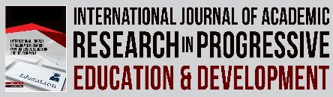
Vol 15, Issue 1, (2026) E-ISSN: 2226-6348

AI in Technical and Vocational Education: A Comprehensive Mini Review

Selvi Rajamanickam, Ridzwan Che’ Rus & Mohd Nazri Abdul Raji
Faculty of Technical and Vocational, Universiti Pendidikan Sultan Idris, Tanjong Malim Perak Malaysia
Corresponding Authors Email: tbernselvi77@gmail.com

DOI Link: http://dx.doi.org/10.6007/IJARPED/v15-i1/27920
Published Online: 27 March 2026
Abstract
Artificial Intelligence (AI), as a phenomenon in education, is progressively considered as a revitalizing power, but little has been said about its application in Technical and Vocational Education and Training (TVET) despite the mounting pressure on institutions to meet the needs of Industry 4.0. This mini review is a synthesis of existing evidence that investigates the use of AI in teaching and learning, workforce development, as well as curriculum design. Defined keywords were used to search the Scopus as well as Google Scholar (August 2025) literature; it included studies related to AI in vocational education settings and excluded the grey or non-English literature. The results show that AI can substantially contribute to workforce preparedness by analyzing predictive skills gaps, micro-credentialing, as well as industry-oriented curricula; to teaching and learning by supporting adaptive platforms, intelligent tutoring, and simulations; alongside redesigning curriculum through flexible and responsive paths in alignment with changing labor markets. However, it remains highly constrained by other factors such as, the digital divide, unequal institution readiness, ethical and data privacy, as well as lack of longitudinal evidence regarding the long-term impact. These issues of conflicting technological innovation and human-related mentoring as well as threats of overdependence on automation are also found in other discourses. AI must be applied to the future in a way that is ethically and policy sound, scalable and fair, as well as as a hybrid that does not replace human teachers. Its applications include AI-based analysis and certification, industry education collaboration, the notions of lifetime learning, inclusiveness, as well as moral responsibility. As mentioned in this review, one must focus on the issues that are yet to be resolved and make use of the opportunities that are available so that the TVET systems can be modified in a manner that would enable them to become equitable, flexible, as well as responsive to the needs of the new workforce.
Keywords: Artificial Intelligence, Technical and Vocational Education, Workforce Development, Curriculum Design, Teaching and Learning

Introduction
Artificial Intelligence (AI) has become one of the most revolutionary technologies of the 21st century that has changed economies, industries, as well as educational systems globally. In this regard, Technical and Vocational Education and Training (TVET) must provide people with the ability to work and to achieve sustainable development (Aljohani et al., 2022; Liu et al., 2022; Tuli et al., 2022). In particular, the decision to implement AI in TVET is particularly timely because vocational education organizations are currently forced to cope with the increasing pressure to re-design their coursework to suit the needs of Industry 4.0, as well as with the rapidly expanding labor market (Omar et al., 2023). Employing AI systems, such as intelligent tutoring technologies, intelligent learning platforms, predictive analytics, as well as others, can help to improve personalized learning, quality of training, and increase employability preparedness (Jemetz and Motschnig, 2024; Liu et al., 2022; Matsunaga and Miyata, 2024). Although there is an increasing interest, the application of AI in TVET is underutilized relative to its application in general education as well as higher education. Our knowledge regarding the relevance of AI-based solutions in the workplace, the possibility to apply it in various socio-economic conditions as well as impact the competencies certifying the corresponding skill and labor market remains to be incredibly large (Muchira et al., 2023). Furthermore, the literature is split, some researchers assume that AI would contribute to the democratization of the access to high-quality vocational training, on the other hand, there are those who fear that the humanization of learning is going to be reduced, the digital divide will become even greater, alongside inequities will continue to increase due to the dependence on some technologies. It also does not address ethical considerations, information privacy, whether TVET institutions, particularly in third world countries, desire to be run on this scale, and so on (Hearn et al., 2023). The main focus of the mini review is to present an overall picture of the current situation in the field of AI in TVET and answer these unanswered questions and identify the opportunities and limitations. The review includes four thematic areas: (i) applications of AI in the teaching and learning process, (ii) AI-enabling assessment and certification, (iii) AI in bridging training to workforce demands, as well as (iv) risks, barriers, and ethical considerations (Mahesh, 2025; Mittoor and Putteti, 2025; Regula, 2025). Together with the new results, this review shows that AI can help make vocational learning more responsive and industry-responsive, but its deployment will need infrastructure, a policy-enabling environment, as well as human capabilities. Ultimately, this mini-review offers insights not only for researchers in education and technology but also for policymakers and practitioners seeking to modernize vocational training for a digital and inclusive future (Gangoda et al., 2023; Mittoor & Putteti, 2025).

Objective
This mini-review aims to:-
Provide a comprehensive overview of AI applications in TVET
Identify existing gaps, and highlight both opportunities and challenges.
This study offers insights for researchers, policymakers, and practitioners seeking to modernize TVET systems in a digital and inclusive era.

Methods
A comprehensive literature search was conducted using Scopus, Google Scholar. Keywords such as ("artificial intelligence" OR "ai" OR "machine learning" OR "deep learning") AND ("technical education" OR "vocational education" OR "career training" OR "skills development") AND ("e-learning" OR "online learning" OR "distance education" OR "digital education") AND ("curriculum" OR "instruction" OR "teaching" OR "training") AND ("assessment" OR "evaluation" OR "feedback" OR "performance") AND ("student engagement" OR "motivation" OR "learning outcomes" OR "success").

Date of searched : 25 August 2025

Inclusive Criteria
• Studies discussing AI’s role in workforce development, teaching and learning, and curriculum design within TVET contexts.
• Studies focusing on the application of AI tools (e.g., ChatGPT, intelligent tutoring systems, predictive analytics, generative AI) in vocational and technical education.
• Studies analyzing the strengths (personalization, efficiency, workforce alignment), limitations (equity gaps, ethical concerns, technological dependency), and potential applications (adaptive curricula, skills gap analysis, job-matching, immersive simulations) of AI in TVET.
• Studies published in English.

Exclusion Criteria
• Studies published in languages other than English.
• Studies addressing vocational education or workforce development without explicit reference to Artificial Intelligence or related technologies.
• Grey literature such as conference abstracts, dissertations, and unpublished reports, to ensure quality and reliability.

Discussion and Result
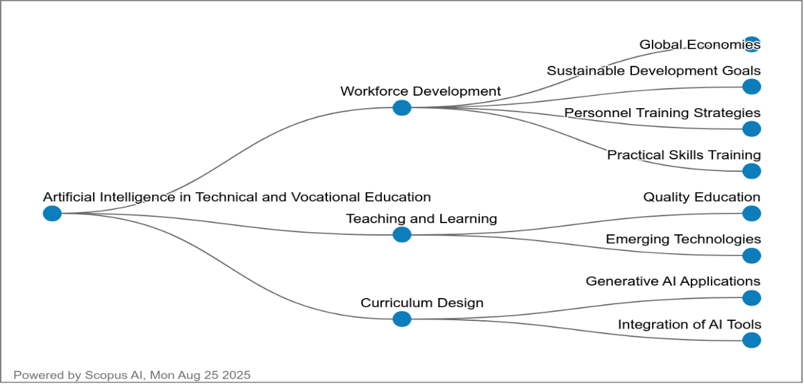

Figure 1 AI in Technical and Vocational Education generated by scopus AI Analyzer

Workforce development in education has become increasingly vital in preparing learners for dynamic global economies, addressing both labor market demands and broader social objectives. Its relevance is underscored by links to the Sustainable Development Goals (SDGs), particularly those promoting quality education, decent work, and reduced inequalities, as well as the need to integrate digital and green skills for sustainable industries (Richter et al., 2025). Current strategies emphasize competency-based curricula, apprenticeships, and lifelong learning, which enhance employability and industry alignment but raise debates over balancing job-specific training with transferable skills and civic education (Keawtavon et al., 2023; Kimura et al., 2022; Renganayagalu et al., 2021; Yamauchi et al., 2023). Practical skills training demonstrates clear benefits in improving workforce readiness, yet longitudinal evidence on its long-term adaptability remains limited. The rise of key technologies including artificial intelligence, big data, and immersive simulations has expanded opportunities for personalized learning and predictive skills gap analysis, though concerns over digital divides, data privacy, and technological dependency persist (Husain et al., 2020; Mian et al., 2020). Practical applications, such as industry partnerships, micro-credentialing, and public–private collaborations, have shown promise in improving workforce readiness, though scalability and sustainability remain challenges, especially in low-resource contexts (Selwyn et al., 2025). As a whole, the literature shows that workforce development bolsters national competitiveness as well as employability, but there has been a gap and inconsistencies in need of inclusivity, ground ethical, and scalable approaches (De Masi et al., 2025). Future research should focus on evaluating long-term outcomes, embedding sustainability in training models, and developing policies that ensure equitable access to workforce-oriented education globally.

Current status of Artificial Intelligence in Technical and Vocational Education based on teaching and learning
Artificial Intelligence (AI) is increasingly shaping teaching and learning in Technical and Vocational Education and Training (TVET), offering new opportunities to enhance quality education and leverage emerging technologies for workforce readiness. In terms of quality education, AI supports adaptive learning, intelligent tutoring, and predictive analytics that personalize instruction and improve assessment, though debates continue over whether such tools risk diminishing the human-centered mentoring essential to vocational learning (Adarkwah, 2025). While AI can democratize access, unequal infrastructure and digital divides threaten to widen disparities across institutions and regions. At the same time, AI’s convergence with emerging technologies such as big data analytics, virtual and augmented reality, and the Internet of Things enables immersive simulations, real-time skills gap analysis, and smarter job-matching systems, strengthening the connection between training and labor markets (Creely & Blannin, 2025). However, challenges related to ethical use, data privacy, and the scalability of advanced tools in resource-constrained contexts remain unresolved, and gaps persist in longitudinal research assessing the sustained impacts of AI in vocational education (El Khayati et al., 2025). Collectively, current evidence suggests that AI has the potential to modernize TVET and prepare learners for Industry 4.0, but future research must prioritize equitable access, robust policy frameworks, and hybrid teaching models that balance technological innovation with human-centered learning (Montalbo, 2022; Othman et al., 2022; Rodzalan et al., 2022).

Current status of Artificial Intelligence in Technical and Vocational Education based on curriculum design
Artificial Intelligence (AI) is reshaping curriculum design in Technical and Vocational Education and Training (TVET), making learning more adaptive, relevant, and aligned with the demands of Industry 4.0 (Modiba, 2025). The latest developments revolve around the AI integration in the curriculum to help students develop flexible and skills-based careers that equip them to operate in dynamic labor markets. Applying generative AI to create content on demand, provide intelligent tutoring, as well as create adaptive assessment systems have proven to positively impact personalized learning experiences and distributed the instructors' workload, but it has also been noted that this technology raises several issues of academic integrity, excessive reliance on automation, along with the risk of losing human judgment in vocational training (Dahake et al., 2025; Faisal et al., 2025; Mohamad et al., 2024; Razia et al., 2023). Likewise, the curriculum can be responsive in the context of the introduction of the AI applications, i.e., simulation platforms, predictive analytics, while recommendation systems has progressed curriculum responsiveness by determining skills gaps, tailoring instruction, as well as bolstering connections between workplace needs and classroom training (Jaiswal et al., 2025). However, several issues persist in ensuring fair accessibility by Artificial Intelligence, data privacy, as well as application of AI in an ethical way in different learning environments. Current gaps include limited longitudinal evidence on the sustained impact of AI-driven curricula and insufficient exploration of how generative AI can balance innovation with inclusivity (Ahmed et al., 2025). Future research should focus on developing hybrid models where AI complements human educators, policy frameworks that regulate responsible integration, and context-sensitive strategies that ensure curriculum design remains learner-centered, ethical, and sustainable (Irish et al., 2025).

Results and Findings
Document by year generated by scopus
Figure 2 shows documents generated by Scopus. Output rises from 6 (2020) to 21 (2023), then peaks at 41 (2024) before a provisional decline to 18 (2025, likely partial-year). The field records a ~62% CAGR (2020–2024); 2024 almost doubles 2023 (+95% YoY) and contributes ~37% (41/111) of all items in the series clear evidence of a take-off phase. Early years (2020–2021) reflect exploratory work introducing AI for TVET; growth in 2022–2023 signals consolidation around applied studies (adaptive tutoring, predictive analytics for placement, automated assessment, competency tracking). The 2024 spike aligns with the mainstreaming of generative AI in education, rapid diffusion of LLM-enabled tools, and a wave of special issues/policy discussions on adoption, pedagogy, and ethics in skills training. The apparent 2025 dip (−56% vs. 2024) is still above 2022 levels and is plausibly explained by indexing lags/partial-year coverage rather than contraction. Implications for field maturity. AI-in-TVET has moved from emergence to early maturity: topic breadth widens (GenAI for simulation/digital twins, adaptive micro-credentials, OJT analytics; integrity, bias, and data-privacy safeguards), while methods shift toward comparative trials and real-world evaluations. We anticipate a normalization of volume post-2024 with greater emphasis on quality multi-site studies, longitudinal outcomes (employability/readiness), teacher upskilling, and cost-effectiveness marking a transition from enthusiasm to evidence-based implementation.

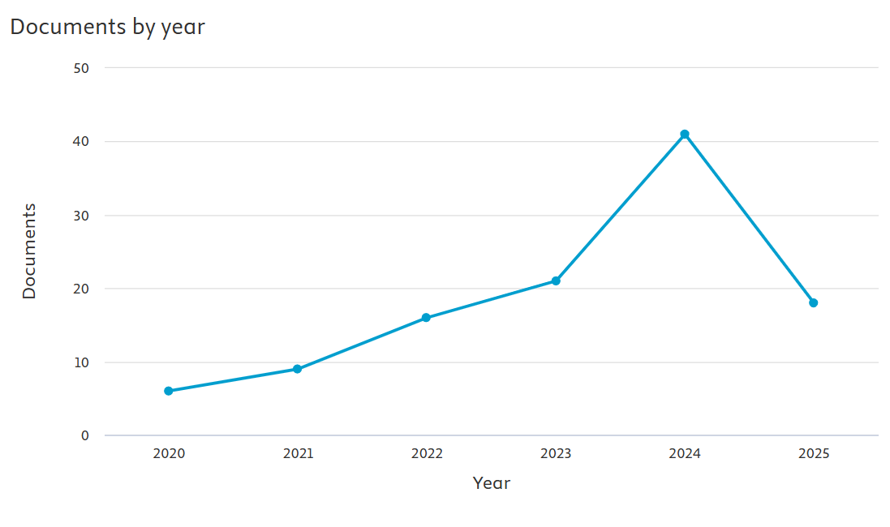

Figure 2 Document by year generated by scopus

Most recent research article journal on Artificial Intelligence in Technical and Vocational Education
The 2025 literature signals a mature pivot from “can AI help education?” to how systems, curricula, and workplaces operationalise GenAI. Policy pieces (Africa-wide outlook; China’s AI–metaverse stance) and administrative adoption (records management) indicate system readiness the governance, data, and interoperability foundations that TVET needs for scalable implementation (e-portfolios/skills passports, secure assessment, audit trails). Pedagogical studies (constructivist integration, creative partnerships, scenario building) align naturally with competency-based TVET via task simulation, digital-twin labs, and AI-assisted feedback. Workforce-facing contributions (UK skills-gap analysis; GenAI pedagogy for work; adult-learning frameworks) sharpen the employability lens, underscoring micro-credentials co-designed with employers, predictive OJT matching, and authentic assessment tied to job tasks. However, the evidence base remains light on TVET-specific outcomes: most papers are policy, conceptual, or qualitative, with few multi-site trials quantifying competency mastery, placement quality, cost-effectiveness, or instructor upskilling. In short, 2025 research provides the scaffolding; TVET now needs rigorous, outcomes-driven studies that prove value at the workshop floor and workplace.

Table 1
Most recent research article journal on Artificial Intelligence in Technical and Vocational Education
Authors | Year | Contribution Area
Ahmed A.-B.; King B.D.; Hiran K.K.; Dadhich M.; Malcalm E. | 2025 | Trends, opportunities, challenges, and future directions of AI in education in Africa
Jaiswal K.; Kuzminykh I.; Modgil S. | 2025 | Understanding the skills gap between higher education and industry in the UK in artificial intelligence sector
Modiba M. | 2025 | Adoption of AI to enhance records management practices in South Africa’s Department of Education
El Khayati M.; Courr A.; Kich I.; Hibbi F.-Z. | 2025 | Integration of AI into Morocco’s high-school computer science curriculum
Creely E.; Blannin J. | 2025 | Creative partnerships with generative AI. Possibilities for education and beyond
Michael; Agyemang; Adarkwah | 2025 | GenAI-Infused Adult Learning in the Digital Era: A Conceptual Framework for Higher Education
Irish A.L.; Gazica M.W.; Becerra V. | 2025 | A qualitative descriptive analysis on generative artificial intelligence: bridging the gap in pedagogy to prepare students for the workplace
De Masi V.; Di Q.; Li S.; Song Y. | 2025 | China’s AI and metaverse policies: implications for academic research
Selwyn N.; Kaviani F.; Strengers Y.; Dahlgren K.; Cumbo B.; Wagner M. | 2025 | Supporting students’ construction of future school scenarios with AI
Richter S.; Giroux M.; Piven I.; Sima H.; Dodd P. | 2025 | Constructivist approaches to integrating AI into marketing education

Conclusion
This mini review highlights that Artificial Intelligence holds significant potential to transform Technical and Vocational Education and Training (TVET) by strengthening workforce development, enhancing teaching and learning, and reshaping curriculum design to meet the demands of Industry 4.0. Evidence suggests that AI can support competency-based training, adaptive instruction, and responsive curricula that better align with labor market needs, thereby improving employability and national competitiveness. However, critical limitations remain, including uneven infrastructure, digital divides, ethical concerns, and limited longitudinal evidence on the sustained impact of AI-driven solutions. Ongoing controversies also persist regarding the balance between technological innovation and human-centered learning, as well as the risks of over-reliance on automation in vocational training. Addressing these gaps requires future research that prioritizes equity, sustainability, and policy frameworks that enable responsible AI integration. Practical directions include the development of hybrid teaching models, scalable AI-enabled assessment tools, and stronger industry–education partnerships. Ultimately, capitalizing on the opportunities of AI in TVET depends on fostering inclusive, ethical, and context-sensitive approaches that ensure technology complements, rather than replaces, the vital human elements of vocational education.

Theoretical and Contextual Contributions
This study makes both theoretical and contextual contributions to the growing body of knowledge on Artificial Intelligence (AI) in Technical and Vocational Education and Training (TVET). From a theoretical perspective, the review extends existing frameworks of technology-enhanced learning by integrating AI within the specific context of competency-based and workforce-oriented education. It synthesizes fragmented literature into a structured understanding of how AI supports teaching and learning, workforce alignment, and curriculum innovation in TVET, thereby contributing to the conceptualization of AI as a catalyst for adaptive, industry-responsive education systems. Furthermore, the study highlights the need for hybrid pedagogical models that balance AI-driven automation with human-centered instruction, enriching theoretical discussions on the intersection between educational technology, employability, and skills development. On the other hand, contextual perspective, provides timely insights into the implementation of AI in TVET systems, particularly within emerging and resource-constrained environments where digital readiness and infrastructure remain uneven. It identifies critical challenges such as the digital divide, institutional capacity, and ethical considerations, offering a nuanced understanding of how AI adoption varies across socio-economic contexts. The findings are especially relevant for policymakers, educators, and practitioners seeking to modernize TVET systems in alignment with Industry 4.0 while ensuring inclusivity and sustainability. By bridging global AI trends with the practical realities of vocational education, this study contributes to the development of context-sensitive strategies that support equitable and scalable AI integration in TVET.

References
Adarkwah, M. A. (2025). GenAI-Infused Adult Learning in the Digital Era: A Conceptual Framework for Higher Education. Adult Learning, 36(3), 149–161. https://doi.org/10.1177/10451595241271161
Ahmed, A.-B., King, B. D., Hiran, K. K., Dadhich, M., & Malcalm, E. (2025). Half a Decade of Artificial Intelligence in Education in Africa: Trends, Opportunities, Challenges and Future Directions. Journal of Engineering Education Transformations, 38(3), 81–100. https://doi.org/10.16920/jeet/2024/v38i3/24246
Aljohani, N. R., Aslam, M. A., Khadidos, A. O., & Hassan, S.-U. (2022). A Methodological Framework to Predict Future Market Needs for Sustainable Skills Management Using AI and Big Data Technologies. Applied Sciences (Switzerland), 12(14). https://doi.org/10.3390/app12146898
Creely, E., & Blannin, J. (2025). Creative partnerships with generative AI. Possibilities for education and beyond. Thinking Skills and Creativity, 56. https://doi.org/10.1016/j.tsc.2024.101727
Dahake, P. S., Santo, V. R., & Panchariya, R. (2025). AI-powered knowledge management in curriculum design and content delivery. In AI Applications and Pedagogical Innovation (pp. 415–453). IGI Global. https://doi.org/10.4018/979-8-3373-5092-9.ch015
De Masi, V., Di, Q., Li, S., & Song, Y. (2025). China’s policies and investments in metaverse and AI development: Implications for academic research. Online Media and Global Communication, 4(1), 109–139. https://doi.org/10.1515/omgc-2024-0041
El Khayati, M., Courr, A., Kich, I., & Hibbi, F.-Z. (2025). Integrating Artificial Intelligence into High-School Computer Science Curriculum: A Perspective Study in Morocco. Journal of Curriculum Studies Research, 7(1), 26–46. https://doi.org/10.46303/jcsr.2025.2
Faisal, S. M., Khan, W., & Ishrat, M. (2025). AI-driven pedagogy and assessment in TVET: Transforming education through AI - Enhancing pedagogy and assessment in TVET. In Integrating AI and Sustainability in Technical and Vocational Education and Training (TVET) (pp. 127–150). IGI Global. https://doi.org/10.4018/979-8-3373-1142-5.ch006
Gangoda, A., Krasley, S., & Cobb, K. (2023). AI digitalisation and automation of the apparel industry and human workforce skills. International Journal of Fashion Design, Technology and Education, 16(3), 319–329. https://doi.org/10.1080/17543266.2023.2209589
Hearn, G., Williams, P., Rodrigues, J. H. P., & Laundon, M. (2023). Education and training for industry 4.0: a case study of a manufacturing ecosystem. Education and Training, 65(8–9), 1070–1084. https://doi.org/10.1108/ET-10-2022-0407
Husain, S. H., Che-Ani, A. I., Affandi, H. M., Nasri, N. M., & Musid, N. A. (2020). Mismatch in supply and demand of building surveying graduates’ skills: A triangulation perspective. Journal of Technical Education and Training, 12(4), 70–80. https://doi.org/10.30880/jtet.2020.12.04.007
Irish, A. L., Gazica, M. W., & Becerra, V. (2025). A qualitative descriptive analysis on generative artificial intelligence: bridging the gap in pedagogy to prepare students for the workplace. Discover Education, 4(1). https://doi.org/10.1007/s44217-025-00435-4
Jaiswal, K., Kuzminykh, I., & Modgil, S. (2025). Understanding the skills gap between higher education and industry in the UK in artificial intelligence sector. Industry and Higher Education, 39(2), 234–246. https://doi.org/10.1177/09504222241280441
Jemetz, M., & Motschnig, R. (2024). Teachers’ Development of Competence in Managing Generative AI Technology: Findings from a Qualitative Interview Series. Proceedings - Frontiers in Education Conference, FIE. https://doi.org/10.1109/FIE61694.2024.10893585
Keawtavon, T., Suamuang, W., & Chomsuwan, K. (2023). Professional Competency Development Using Self-Directed Learning via on the Job Training. 8th International STEM Education Conference, ISTEM-Ed 2023 - Proceedings. https://doi.org/10.1109/iSTEM-Ed59413.2023.10305790
Kimura, T., Kurachi, Y., & Sugo, T. (2022). Decreasing wage returns to human capital: Analysis of wage and job experience using micro data of workers☆. Journal of the Japanese and International Economies, 66. https://doi.org/10.1016/j.jjie.2022.101217
Liu, X., Gong, Y., & Liu, L. (2022). The Model Architecture of AI Technology in Higher Vocational English Classroom Teaching. Proceedings - 2022 3rd International Conference on Education, Knowledge and Information Management, ICEKIM 2022, 239–242. https://doi.org/10.1109/ICEKIM55072.2022.00060
Mahesh, P. (2025). Theoretical foundations of AI and sustainability in TV. In Integrating AI and Sustainability in Technical and Vocational Education and Training (TVET) (pp. 61–81). IGI Global. https://doi.org/10.4018/979-8-3373-1142-5.ch003
Matsunaga, H., & Miyata, K. (2024). Emerging Approaches in CG Education Aimed at Enhancing Visual Communication Skills through Reverse Engineering. In S. S.N. (Ed.), Proceedings - SIGGRAPH 2024 Educator’s Forum. Association for Computing Machinery, Inc. https://doi.org/10.1145/3641235.3664430
Mian, S. H., Salah, B., Ameen, W., Moiduddin, K., & Alkhalefah, H. (2020). Adapting universities for sustainability education in industry 4.0: Channel of challenges and opportunities. Sustainability (Switzerland), 12(15). https://doi.org/10.3390/su12156100
Mittoor, G. K. R., & Putteti, S. (2025). From data to action: Optimizing resources in TVET through AI and big data insights. In Integrating AI and Sustainability in Technical and Vocational Education and Training (TVET) (pp. 177–187). IGI Global. https://doi.org/10.4018/979-8-3373-1142-5.ch008
Modiba, M. (2025). Adoption of artificial intelligence to enhance records management practices at Gauteng Department of Education in South Africa. Collection and Curation, 44(1), 9–17. https://doi.org/10.1108/CC-12-2023-0044
Mohamad, A. F. B., Suhaimin, M. K. N. B., Akmal, S. B., Rahim, H. R. B. A., Mahmood, W. H. B. W., & Hashim, H. S. B. (2024). Enhancing TVET Graduate Employability Through AI Integration: An AHP Analysis in the End-of-Life Vehicle (ELV) Sector. 2024 International Conference on TVET Excellence and Development, ICTeD 2024, 59–64. https://doi.org/10.1109/ICTeD62334.2024.10844638
Montalbo, A. (2022). Experiential Learning and Job Satisfaction of Students in a Technological University in the Philippines. Journal of Technical Education and Training, 14(1), 27–37. https://doi.org/10.30880/jtet.2022.14.01.003
Muchira, J. M., Kiroro, F., Mutisya, M., Ochieng, V. O., & Ngware, M. W. (2023). Assessing technical vocational education and training institutions’ curriculum in Kenya: What strategies can position the youth for employment? Journal of Adult and Continuing Education, 29(2), 563–582. https://doi.org/10.1177/14779714221145863
Omar, M. K., Muhamad, W. M. W., Ismail, N., Zakaria, A., & Kadir, K. M. (2023). Employability Skills and Career Development Self-Efficacy as Indicators for Workforce Success. Journal of Technical Education and Training, 15(3 Special Issue), 118–130. https://doi.org/10.30880/jtet.2023.15.03.011
Othman, S., Hussain, M. A. M., Zulkifli, R. M., & Saud, M. S. (2022). On-the-Job Training in Vocational College: Issue and Improvement Plan. International Journal of Learning, Teaching and Educational Research. https://doi.org/10.26803/ijlter.21.12.7
Razia, B., Awwad, B., & Taqi, N. (2023). The relationship between artificial intelligence (AI) and its aspects in higher education. Development and Learning in Organizations, 37(3), 21–23. https://doi.org/10.1108/DLO-04-2022-0074
Regula, K. C. (2025). AI and cybersecurity: A symbiotic relationship for sustainable technical and vocational education. In Integrating AI and Sustainability in Technical and Vocational Education and Training (TVET) (pp. 299–317). IGI Global. https://doi.org/10.4018/979-8-3373-1142-5.ch015
Renganayagalu, S., Mallam, S. C., & Nazir, S. (2021). Effectiveness of VR Head Mounted Displays in Professional Training: A Systematic Review. Technology, Knowledge and Learning, 26(4), 999–1041. https://doi.org/10.1007/s10758-020-09489-9
Richter, S., Giroux, M., Piven, I., Sima, H., & Dodd, P. (2025). A Constructivist Approach to Integrating AI in Marketing Education: Bridging Theory and Practice. Journal of Marketing Education, 47(2 Special Issue: Artificial Intelligence and the Future of Marketing Education), 94–111. https://doi.org/10.1177/02734753241288876
Rodzalan, S. A., Noor, N. N. M., Abdullah, N. H., & Saat, M. M. (2022). TVET Skills Gap Analysis in Electrical and Electronic Industry: Perspectives from Academicians and Industry Players. Journal of Technical Education and Training, 14(1), 158–177. https://doi.org/10.30880/jtet.2022.14.01.014
Selwyn, N., Kaviani, F., Strengers, Y., Dahlgren, K., Cumbo, B., & Wagner, M. (2025). “We’re already experts in school, right?”: Supporting students’ construction of future school scenarios. Futures, 166. https://doi.org/10.1016/j.futures.2025.103541
Tuli, N., Singh, G., Mantri, A., & Sharma, S. (2022). Augmented reality learning environment to aid engineering students in performing practical laboratory experiments in electronics engineering. Smart Learning Environments, 9(1). https://doi.org/10.1186/s40561-022-00207-9
Yamauchi, F., Kim, T., Lee, K. W., & Tiongco, M. (2023). Can German vocational training combat skill shortages in developing countries? Evidence from dual training system in the Philippines. Review of Development Economics, 27(4), 2470–2488. https://doi.org/10.1111/rode.13047

